[algorithms - Combining merge sort and insertion sort - Computer Science Stack Exchange](https://cs.stackexchange.com/questions/68179/combining-merge-sort-and-insertion-sort)

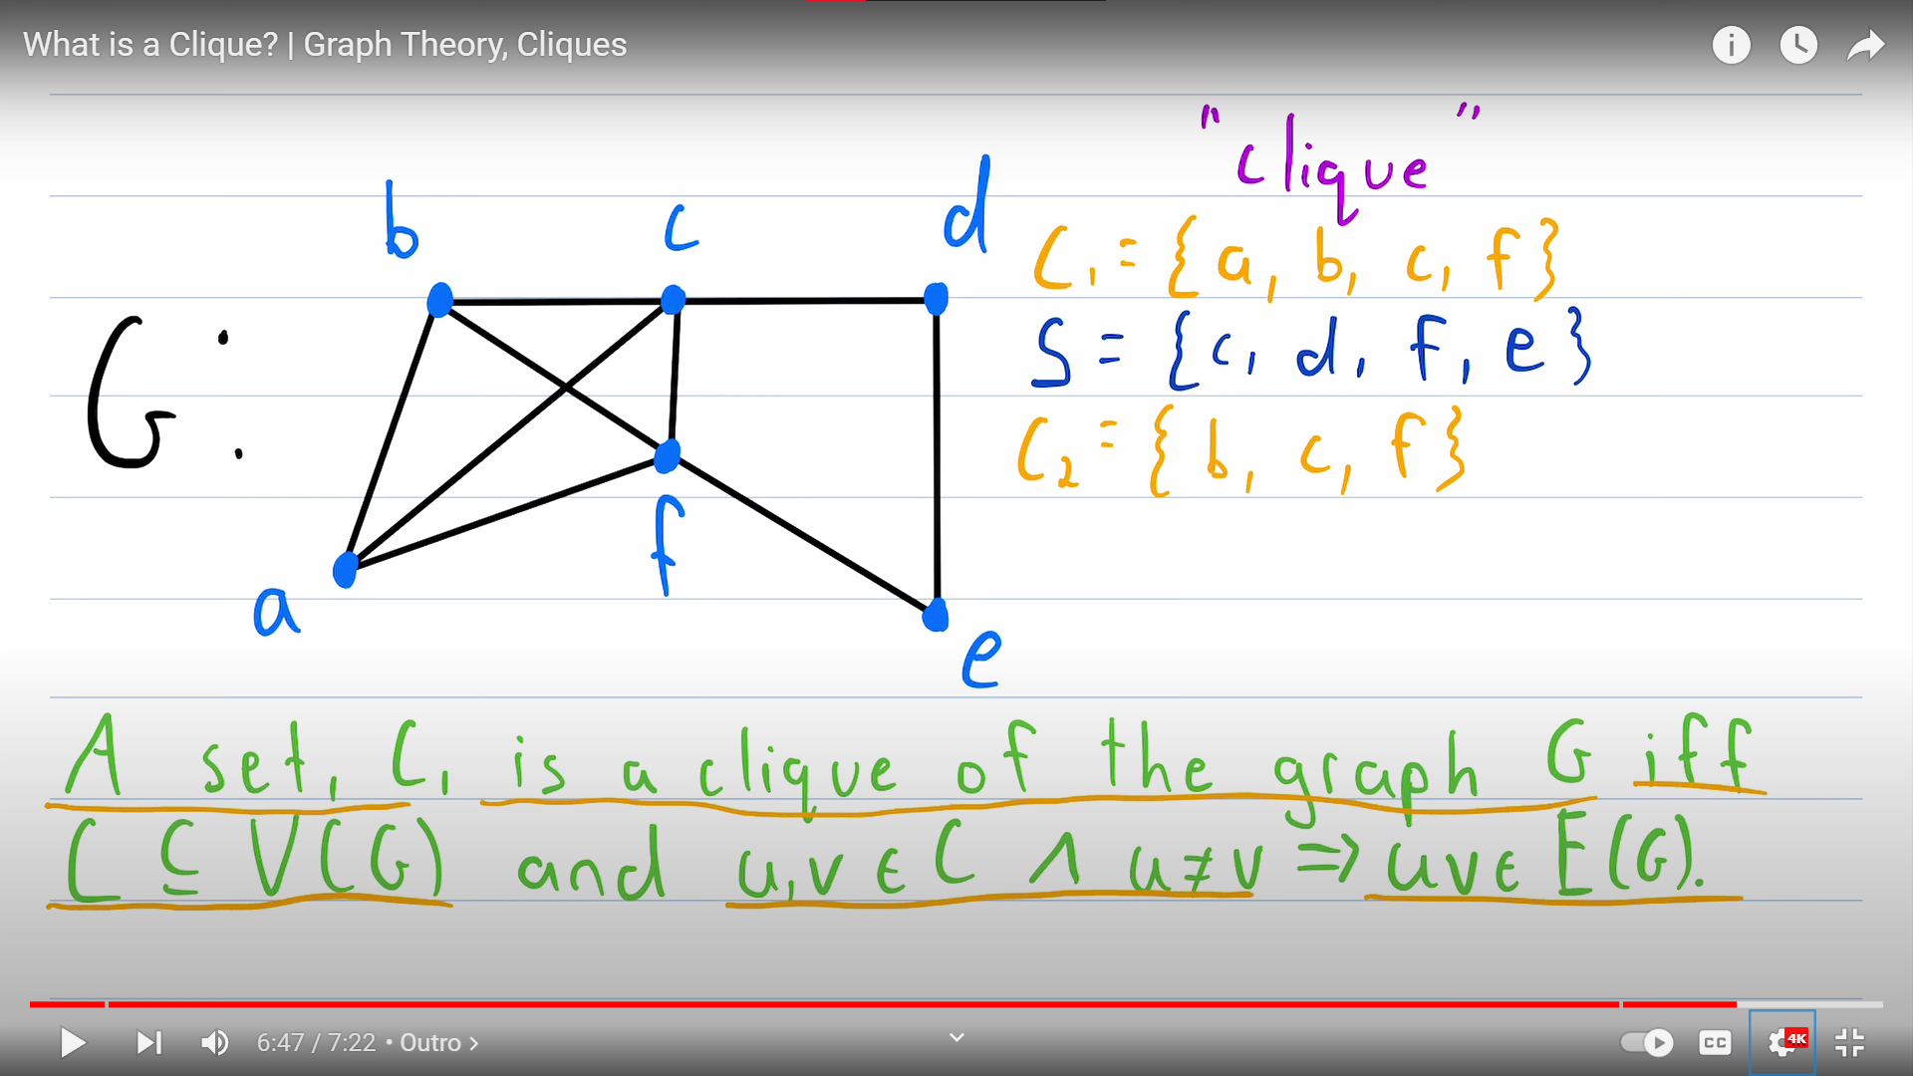

[What is a Clique? | Graph Theory, Cliques - YouTube](https://www.youtube.com/watch?v=nBrFC0STApo&t=370s)

[Algorithms: GATE CSE 2007 | Question: 41 (gateoverflow.in)](https://gateoverflow.in/1239/gate-cse-2007-question-41)

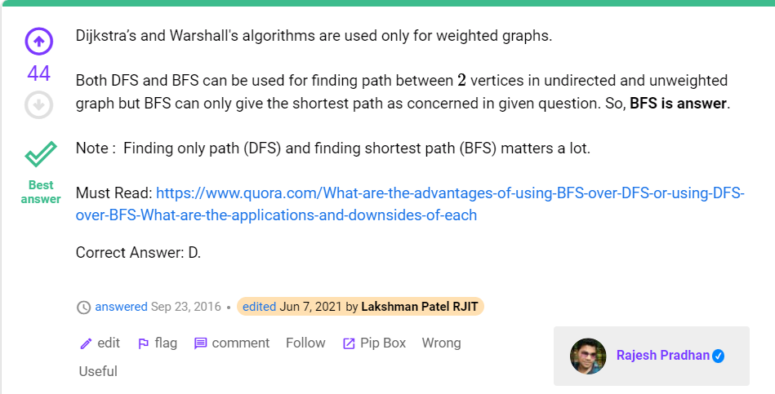

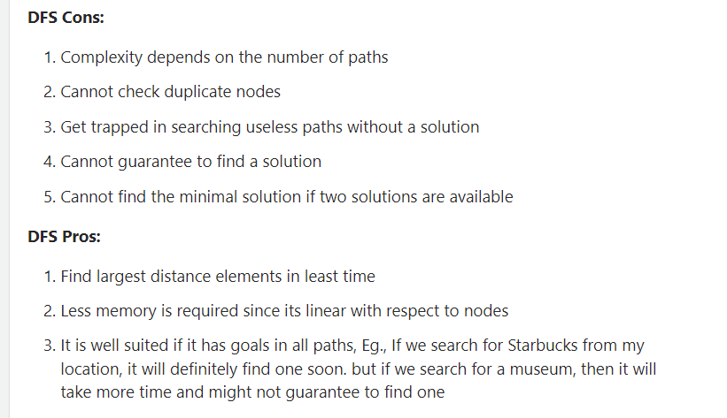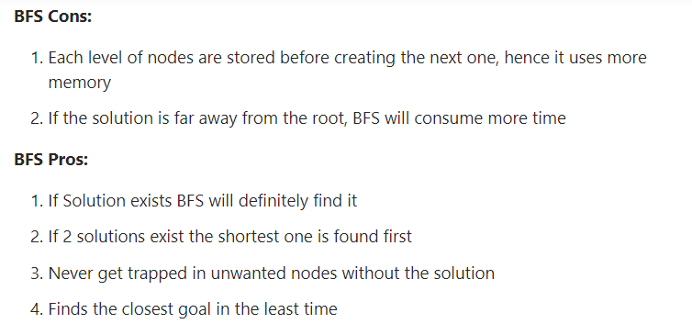

Imp q) [Algorithms: GATE CSE 2008 | Question: 45 (gateoverflow.in)](https://gateoverflow.in/457/gate-cse-2008-question-45)

v.imp comments: <https://gateoverflow.in/457/gate-cse-2008-question-45?show=96573#c96573>

<https://gateoverflow.in/457/gate-cse-2008-question-45?show=250702#c250702>

<https://gateoverflow.in/457/gate-cse-2008-question-45?show=259736#c259736>

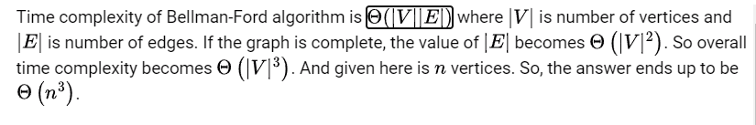

[All Topological Sorts of a Directed Acyclic Graph - GeeksforGeeks](https://www.geeksforgeeks.org/all-topological-sorts-of-a-directed-acyclic-graph/)

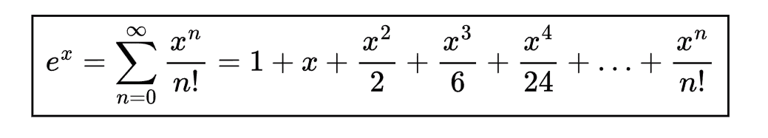

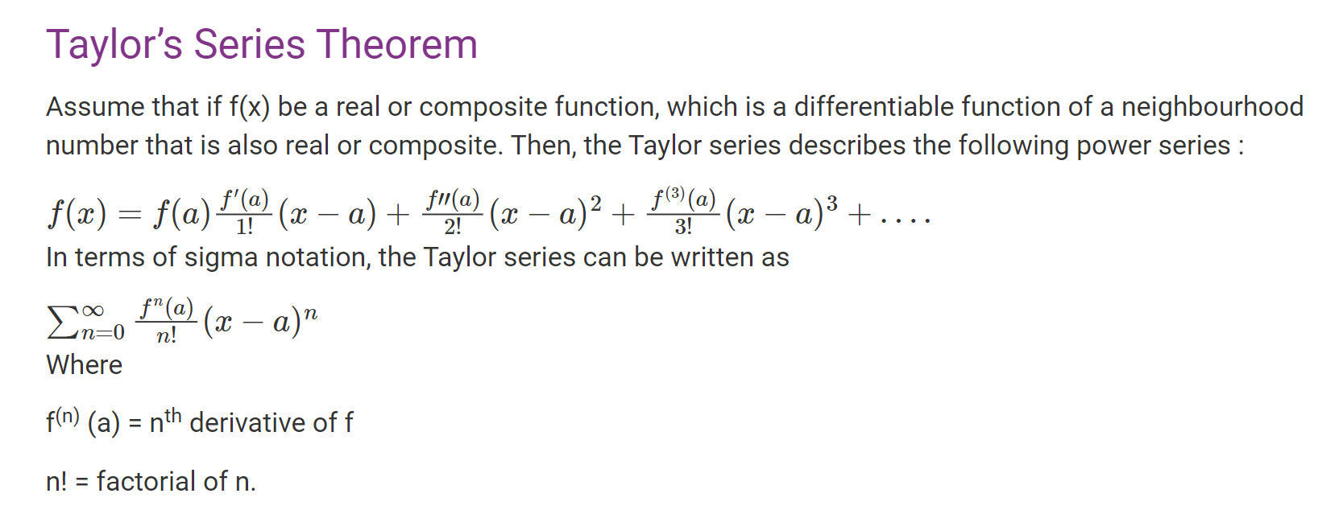

Q) [Algorithms: GATE CSE 2020 | Question: 40 (gateoverflow.in)](https://gateoverflow.in/333191/gate-cse-2020-question-40)

Best Solution by HET PATEL :-

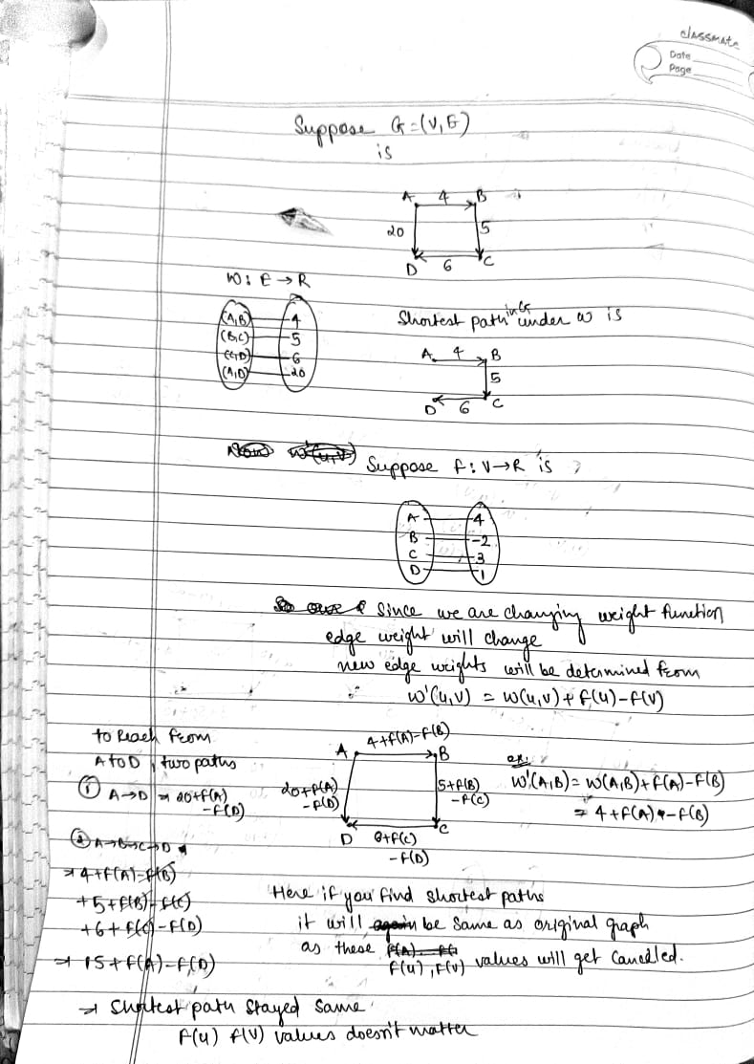

Let G be a graph, **A vertex v of G is called a pendant vertex if and only if v has degree 1**